7.Write a Pandas program to create a Pivot table and find the maximum and minimum sale value of the items.
Program:
import pandas as pd

data = pd.read_csv("sales.csv")

pivot = pd.pivot_table(data, index="Item", values="Sale", aggfunc=["max", "min"])

print(pivot)
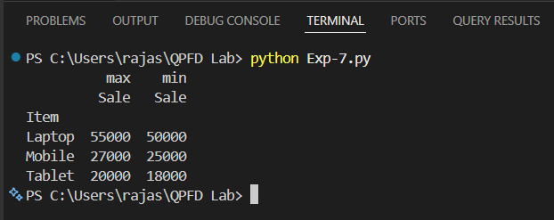
Output:
Result
The program successfully created a Pivot Table and displayed the maximum and minimum sale values for each item.
8.Write a Pandas program to create a Pivot table and find the item wise unit sold.
Program:
import pandas as pd

data = pd.read_csv("sales.csv")

pivot = pd.pivot_table(data, index="Item", values="Units_Sold", aggfunc="sum")

print(pivot)
Output:
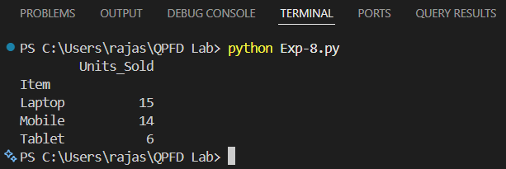
Result:
The program successfully created a Pivot Table and displayed the total item-wise units sold.

